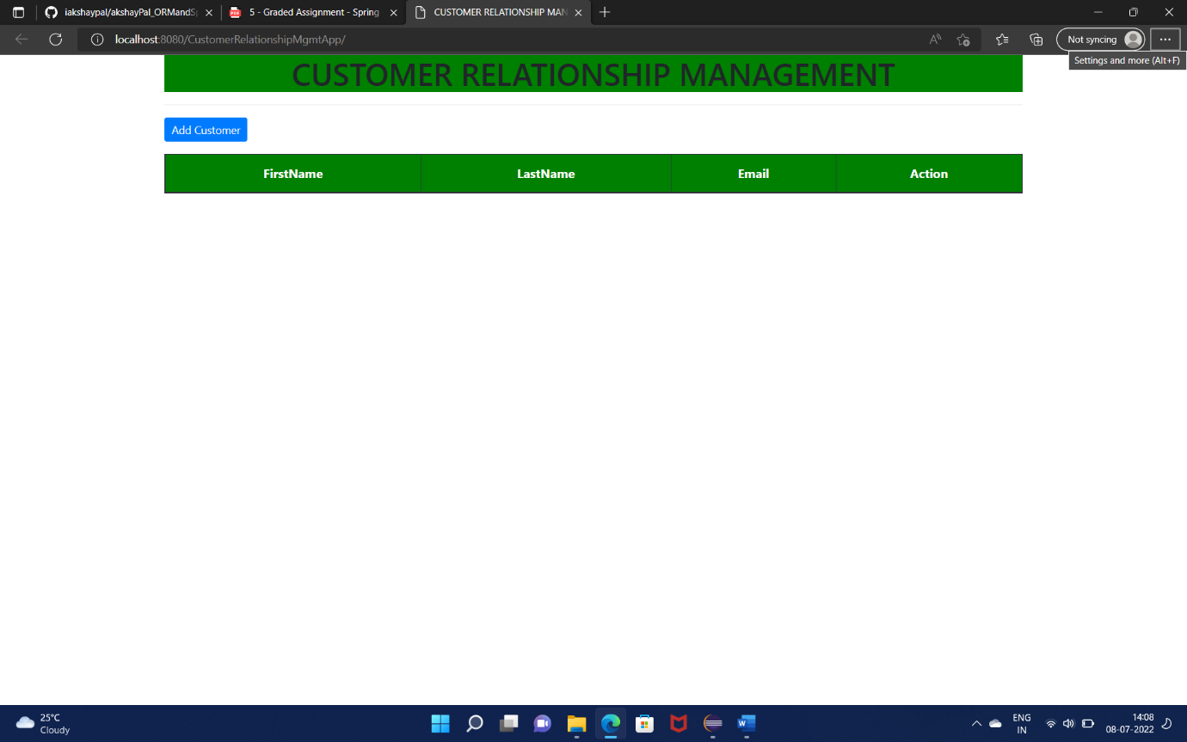

The above is a sample template of the main page.

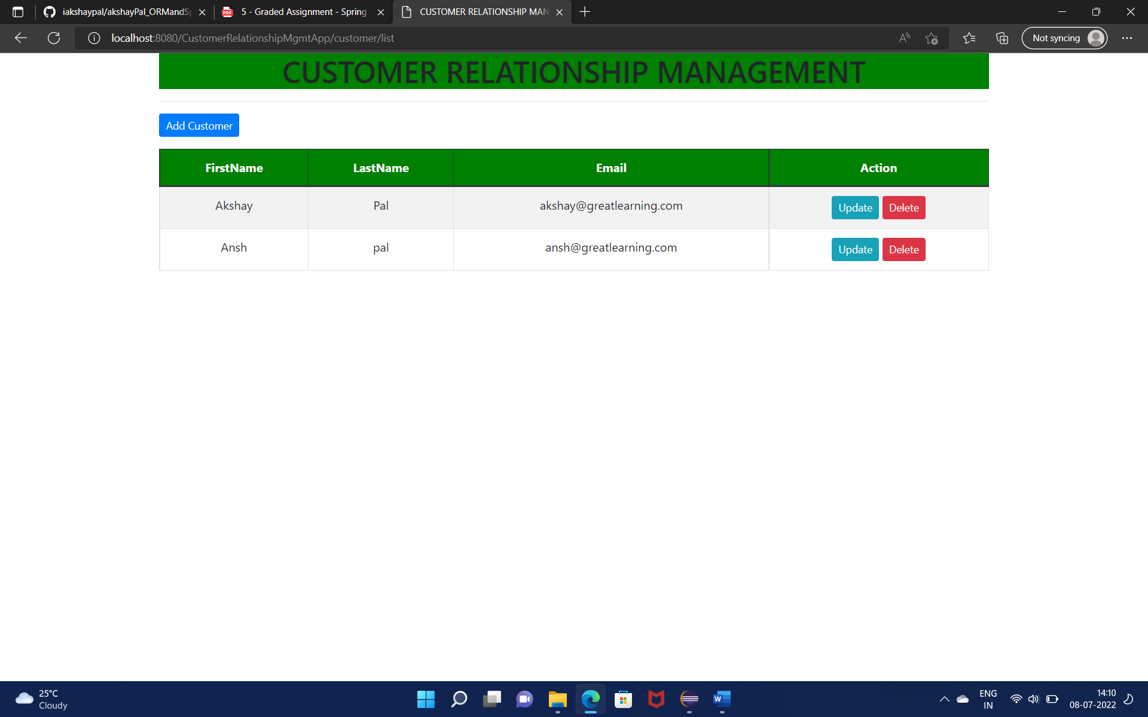

The above is a sample template of the main page with some data.

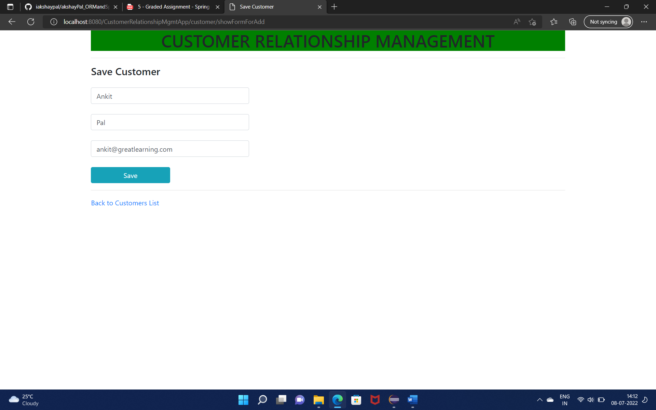

Upon Clicking Add Customer button redirected to a new form page, wherein the details of Ankit Pal added and saved.

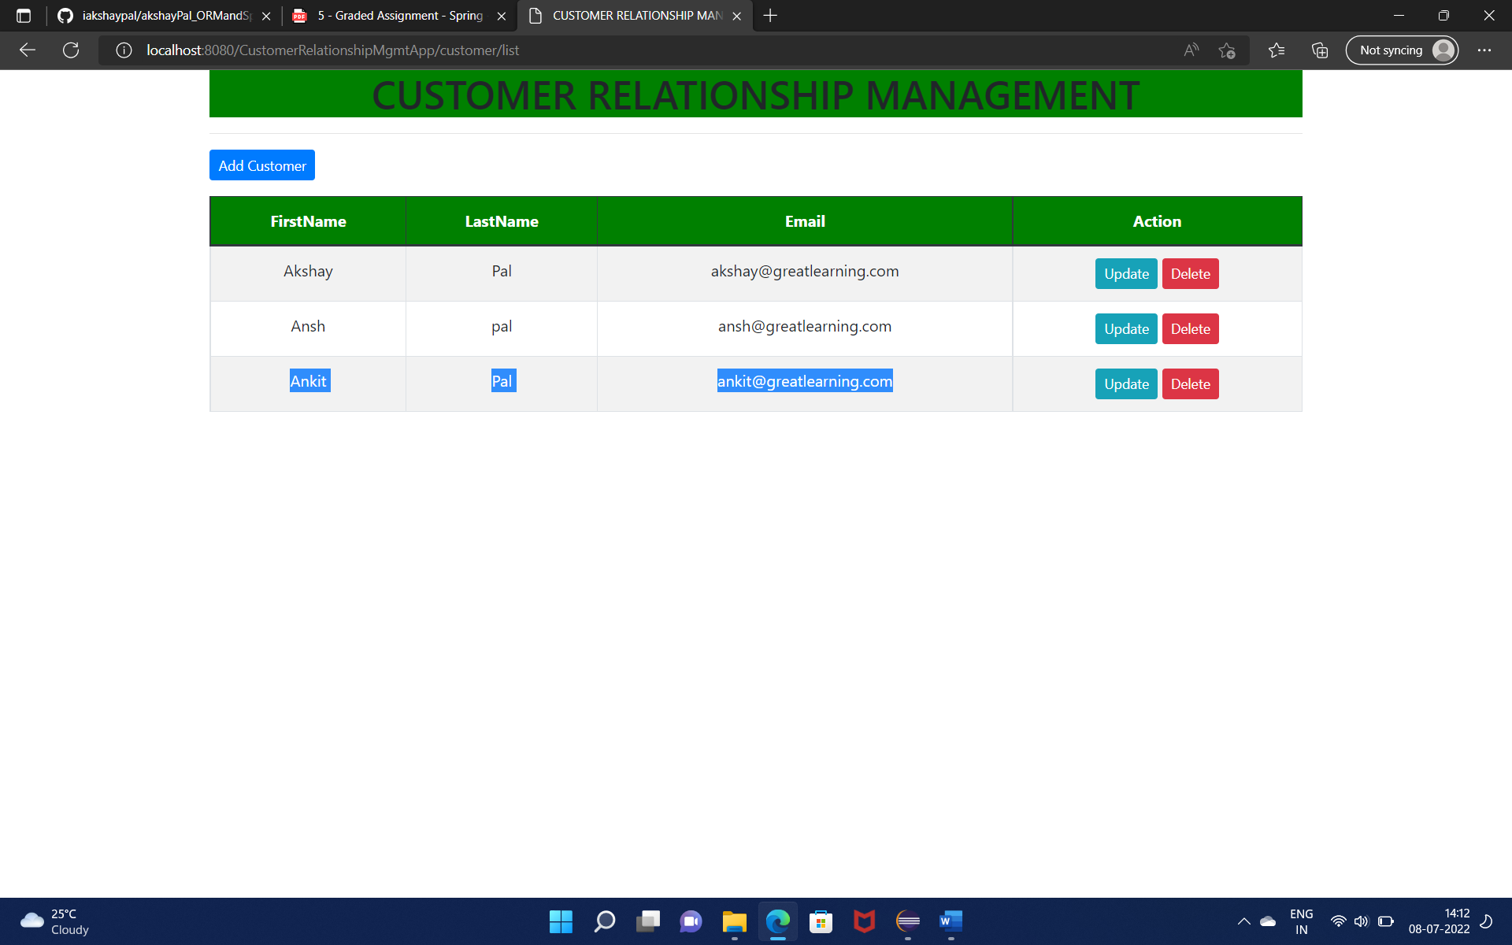

Updated list of customers after adding a new customer Ankit Pal

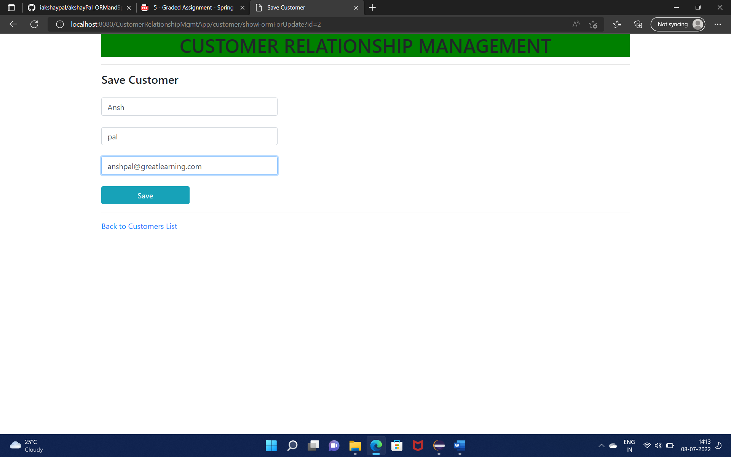

Updating the email address for customer Ansh pal and saving it with anshpal@greatlearning.com

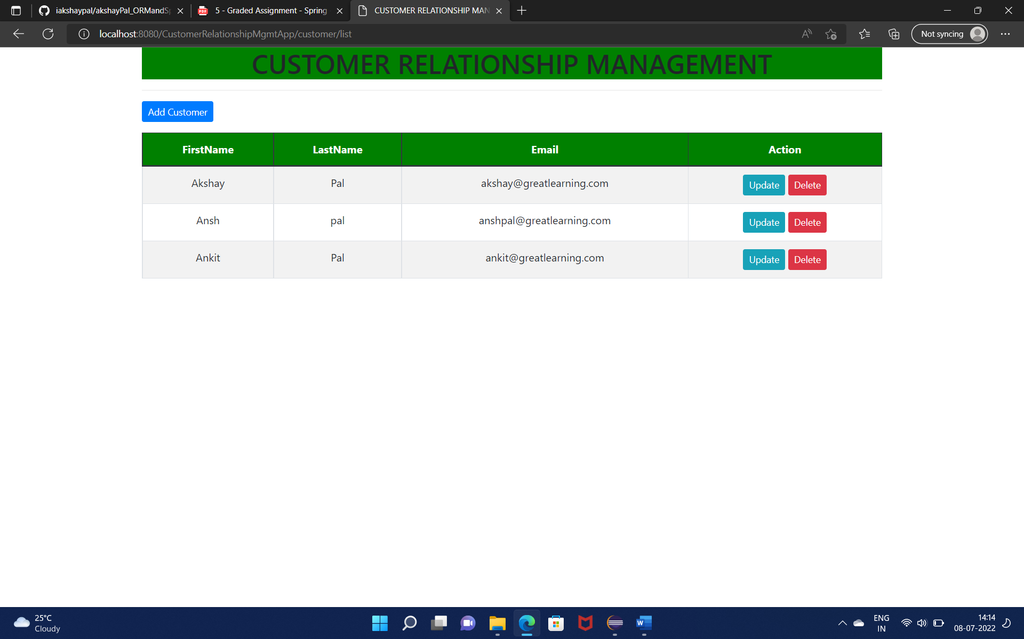

Updated list after updating the email of customer Ansh Pal

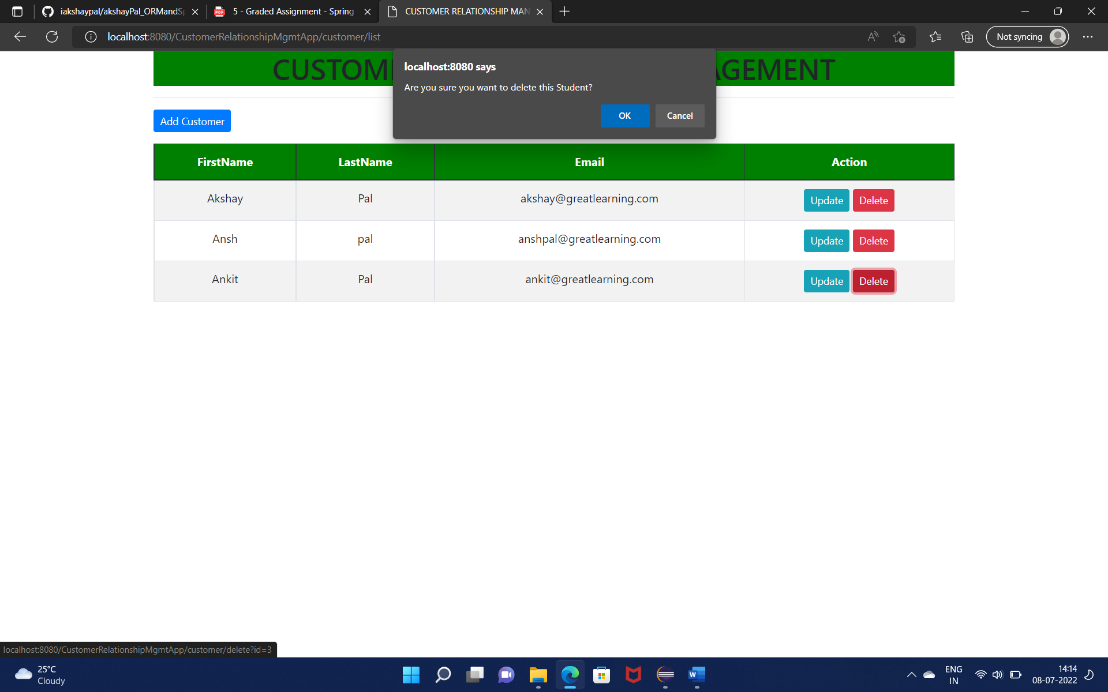

upon clicking the delete button, a pop up is generated

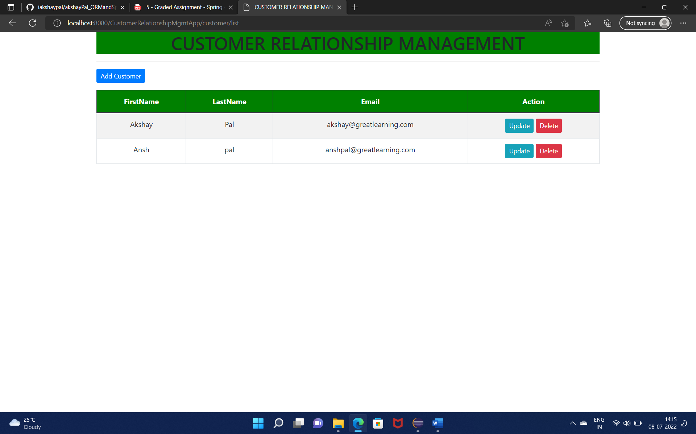

Updated list of customers upon deleting customer Ankit Pal